Product Specification of PLC Video & Surveillance System

Rev 0.3

Oct 27 2005

Prepared by : Welson Hsiao
Mike Yeh

Checked by : Sam Yeh

Approved by : Sam Yeh

Document History

Date | Revision | Remark
9-21-2005 | 0.1 | 1st draft for internal review
10-3-2005 | 0.2 | - Change DVI/HDCP to DVI in section 3.1  - Put section 3.2 LED Video Synchronization On as an optional feature. If chip does not provide that feature, this will be eliminated accordingly  - Put a note in section 3.2 Feature  - Eliminate IR controller in section 3.3 Accessory  - Modify SW Architecture in section 7  - Eliminate PPPoE and put a note in section 8.1  - Eliminate remote live TV support in section 8.1
10-27-2005 | 0.3 | 1. Move Video component, DVI 3.1  2. Move Audio SPDIF 3.1

Content

- Overview
- System Application Configuration
- Product requirement & characteristics
  - Physical
  - Electrical
  - Environmental
  - Connector
  - LED
  - MTBF hours
  - Certification
  - Performance
  - Feature
- System architecture
- Hardware architecture
- Hardware specification
- Software architecture
- Software spec & flow chart
- ID

- Overview

The most significant application of the digital home concept is to have the video and/or audio streaming be distributed to any area inside the house, where the user could enjoy the entertainment any where in home. To materialize this concept, there are two key factors, i.e.,
      - home network with enough bandwidth to accommodate video signal
      - multi-media streaming flowing in home network with quality of service to achieve the perceptual video quality

The video streaming transported over the home network needs very big bandwidth. For example, it requires 4 – 9 Mbps for SDTV ( standard definition TV ) in MPEG2 format and 20Mbps for HDTV ( high definition TV ) in MPEG2 format. In current home network technology, IEEE802.11g & 802.11a, IEEE802.3 and the HomePlug AV are probably the ones qualified to provide the big enough bandwidth. IEEE802.11g & IEEE802.11a are wireless LAN based technology. IEEE802.3 is Ethernet cable LAN based technology, which needs wiring. HomePlug AV is power wire LAN based technology, which have already built inside house.

There is a very unique characteristics in video, i.e., it is real time and sensitive in delay, jitter. There are three potential sources which may cause the poor quality of video. The 1st is the MEPG2 encoder which transforms the digitized video signal to a bandwidth-less compressed signal. Then, the compressed video signal is transmitted over the home network. The noise incurred in the home network is the 2nd problem source to affect the video quality. Then the decoder in receiver must uncompress signal and recover to the original signal. In other words, effective algorithm must be adopted to minimize the impact by the imparity caused by encoder, home network and decoder. Quality of service is in general the terminology used to describe the methodology to maintain the level of perceptual quality by end user

From the above statement it sounds bandwidth inside house seems no more to be the barrier to distribute the video streaming. Instead, how to have the video streaming maintain the perceptual quality is the most challenging work. Due to people are used to the TV quality, any imparity on frame loss, visual distortion, visual freeze and vague, etc., are not accepted by people. Later, maybe in 2006 many countries will commercially start broadcasting HDTV, people at that time instant will have higher perceptual quality on video. That means the challenge to seamless distribute video streaming inside house will be in higher level.

The PLC ( Power Line Communication ) video & surveillance system which consists of three elements, i.e., PLC video & surveillance gateway, adaptor & IP camera. The PLC video & surveillance gateway is a media gateway or server inside house to provide the function of entertainment and surveillance in residential environment. The adaptor is a remote receiver to decode & recover the signal for TV set. The IP camera is a surveillance device. The transport medium used to fulfill the function is the built-in AC power wire in house. This is very suitable for typical house environment application because the addition of new function does not need to deploy new wire, which won’t damage the existing decoration. This is also suitable for some historical buildings. In these environments, it is not allowed to change the current architecture to accommodate the new wiring. Since the AC power wire which has been built in the house can be used as the transport medium in PLC technology, it does not need to deploy new wire.

The input video signal, either from terrestrial TV or DVD player or CATV or Internet, is received by the PLC video & surveillance gateway and then re-distributed to the TV sets in different areas or rooms via the built-in power wire. There will be an adaptor connected to AC receptacle and AV input of TV set, respectively. The adaptor decodes the received signal and recovers it to the original signal showing on TV screen. The user in each area or room can do independent and remote control by typical IR remote controller. Depending on the location of AC receptacle, the remote TV set can be located accordingly. This will create the so-called environment of enjoying entertainment anywhere and anytime which is one of the objectives the digital home is looking for. If the input video signal is in analog form, the PLC video & surveillance gateway will perform the digitization on signal in MPEG2 or MPEG4 or H.264 format. The digitized signal then is sent through the pipe of AC power wire. If the input video signal is in digital form, the PLC video & surveillance gateway will receive the digital video signal and inject it into the pipe of AC power wire.

For surveillance function, there are IP cameras located in different spots of the house to continuously record the designated scene of the house. The captured surveillance signal is transmitted to the PLC video & surveillance gateway either by WiFi-compliant IEEE802.11x or by PLC technology. For security concern, the captured surveillance signal is stored in PLC video & surveillance gateway for 30 seconds and 3 frames per seconds. In other words, the memory device of PLC video & surveillance gateway has always 90 frames. The later coming frame will sequentially override the formerly stored frame. There is motion detection feature. When an intruder entering the house, except the captured surveillance signal by IP camera is recorded in the PLC video & surveillance gateway, the motion detection feature will enable the PLC video & surveillance gateway to send the short message via Internet to the designated people or security house to highlight the warning of house security. In the other way, the owner of the house could remotely access the PLC video & surveillance gateway to have a look of her or his house. The access can be done from anywhere around the world as long as there is a display device connected to Internet. In other words, when the end user is out, conditioned on the PLC video & surveillance gateway being turned on, a two-way surveillance function can be easily executed

- System Application Configuration

In terms of application, there are various configurations depending on the WAN access devices used and technology used to transmit the captured signal in surveillance. The following 4 figures illustrate the possible ones. The PLC video & surveillance system can be applied in POTS-based ADSL system or power line-based PLC system.

Since there are various configurations on video formats, number of streaming, SDTV or HDTV, the following table is used to define the development phases and its corresponding configuration.

 | Configuration
Phase I | - MPEG- 2, 4 , JPEG, WMV , WMA, MP3  - Single video streaming  - WiFi for IP camera  - SDTV  - Video source : DVD player,
Phase II | - H.264  - Two video streamings  - PLC for IP camera ( This could be moved to phase I in case )  - HDTV  - Video source : CATV, terrestrial TV
Phase III | 1. Video source : IP TV with and without CA system

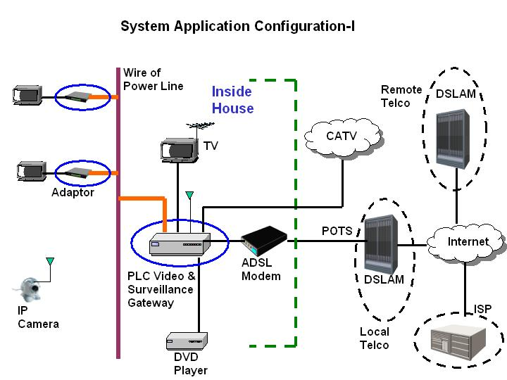

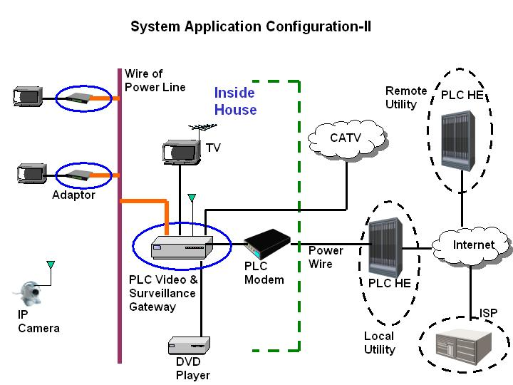

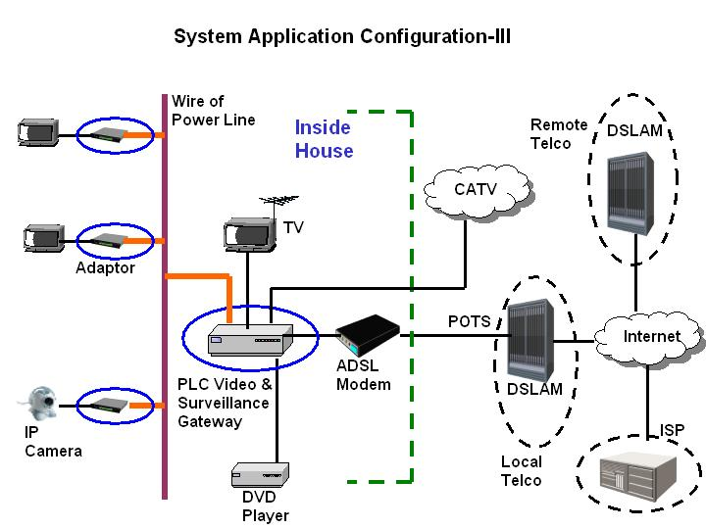

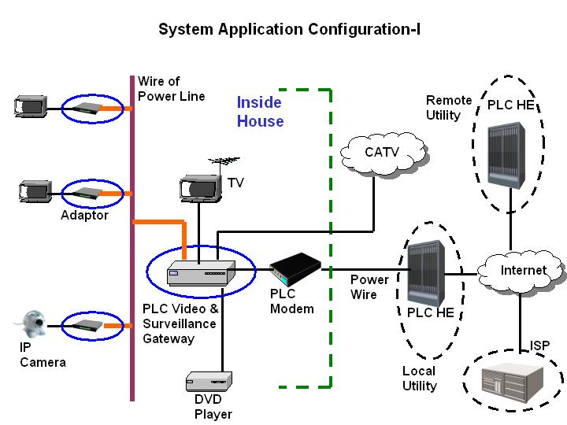

- Product Requirement & Characteristics

Since there are three elements of the PLC video & surveillance system, the common requirement & characteristics will be described as the system requirement & characteristics in section 3.1. Then the individual requirement & characteristics of each element will be highlighted in section 3.2 – 3.4, respectively.

3.1. System Requirement & Characteristics

The followings are the common requirement for the whole system

- Environment

  - Operation temperature ( ambient ) : 0º C – 40º C
  - Storage temperature : 0º C – 70º C
  - Relative humidity : 0% - 90%
- MTBF hours : 20000 hours
- Certification : CE, FCC, UL
- Features
  - Use existing in-house AC power wire as the transport medium & require no wiring for system installation
  - Plug & play
  - NTSC/PAL/SECAM support
  - Single video streaming support
  - MPEG-2 MP@ML format for video encoding & decoding
  - MPEG-4, WMV JPEG support
  - MP3 support
  - SDTV support
  - Video output : Composite, S-video
  - Audio output : Stereo
  - Remote IR controller on video streaming
  - JPEG format for captured surveillance signal
  - 4 ( maximum ) IP camera support
  - Remote access to the stored surveillance signal
  - IP camera with WiFi compliant IEEE802.11g

3.2. Requirement & Characteristics of PLC Video & Surveillance Gateway

- Physical

  - Dimension : < 40cm x 20cm x 4cm
  - Weight : < 1000g excluding power adaptor

- Electrical

  - Input power : 110 or 230VAC
  - Power consumption : < 30W

- Connector

  - RJ-45 x 1 for WAN access device
  - RJ-45 x 1 for management configuration
  - AC receptacle
  - Power ON/OFF switch
  - Reset switch
  - Composition I/O connector for video
  - S-video I/O connector for video
  - Component I/O connector for video
  - Stereo L/R I/O connector for analog audio
  - SPDIF ( coaxial ) I/O connector for digital audio
  - IR blaster

- LED

  - POWER ON/OFF
  - WAN Link ON
  - Power Link ON ( referring to power-wire-based LAN )
  - Surveillance ON
  - Video Synchronization ON ( option )

- Label

  - Name : CE, FCC, UL label, MAC
  - Dimension : per the enclosure-fit-in and standard size used in
AcBel
  - Content : per the normal one used in CE, FCC, UL & MAC label
  - Symbol : per the normal one used in CE, FCC, UL & MAC label
  - Material : normal

- Packing

  - Packing architecture : gift box, carton & bulk
  - Gift box and carton cosmetic : original color
  - Printing on gift box : None
  - Printing on carton : Sign of “direction on position” & “ moisture avoidance”, etc, as the normal one
  - Accessory inside carton : AC power cord, AV cord, IR blaster, user manual
  - Material requirement : Normal
  - Transportation : Land, sea & air

- Accessory

  - AC power cord
  - AV Cord
  - IR blaster
  - User manual

- Feature

  - Web server for surveillance
  - Intruder detection in surveillance
  - Memory supporting to store 3 frames per seconds in JPEG format & 30 seconds continuously recorded video by IP camera
Note : This is the minimum requirement

3.3. Requirement & Characteristics of Adaptor

- Physical

  - Dimension : < 15cm x 10cm x 3cm
  - Weight : < 700g including power adaptor

- Electric

  - Input power : 110 or 230VAC
  - Power consumption : < 15 W

- Connector

  - Input Select ( composite or s-video or component )
  - Power ON/OFF
  - AC receptacle
  - Composite output connector for video
  - S-video output connector for video
  - Component output connector for video
  - DVI output connector for video
  - Stereo L/R output connector for analog audio
  - SPDIF ( Coaxial ) output connector for digital audio

- LED

  - Power ON/OFF
  - Power Link ON ( referring to power-wire-based LAN )
  - Video synchronization

- Label

  - Name : CE, FCC, UL and MAC
  - Dimension : per the enclosure-fit-in and standard size used in
AcBel
  - Content : per the normal one used in CE, FCC, UL & MAC label
  - Symbol : per the normal one used in CE, FCC, UL & MAC label
  - Material : normal

- Packing

  - Packing architecture : gift box, carton & bulk
  - Gift box and carton cosmetic : original color
  - Printing on gift box : None
  - Printing on carton : Sign of “direction on position” & “ moisture avoidance”, etc., as the normal one
  - Accessory inside the carton : AC power cord, AV cord, user manual
  - Material requirement : Normal
  - Transportation : Land, sea & air

- Accessory

  - AC power Cord
  - AV cord
  - User manual

3.4. Requirement & Characteristics of IP camera

All the product requirement & characteristics of IP camera are following the ones made from the 3-party vendor. In the 1st phase development work, IEEE802.11g will be used to transmit the captured signal to PLC video & surveillance gateway. In the 2nd phase development work, PLC embedded module is considered to integrate with the camera and become the PLC-based IP camera.

- System architecture

The system architecture is illustrated by the following figure

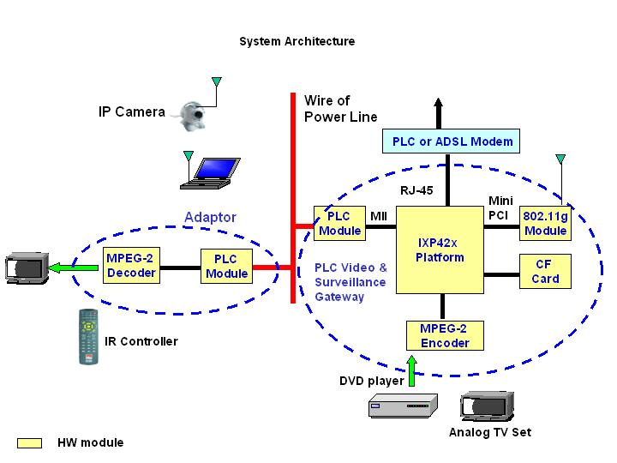

- Hardware Architecture

Based on the system architecture, the hardware architecture are shown as follows accordingly.

  - PLC Video & Surveillance Gateway

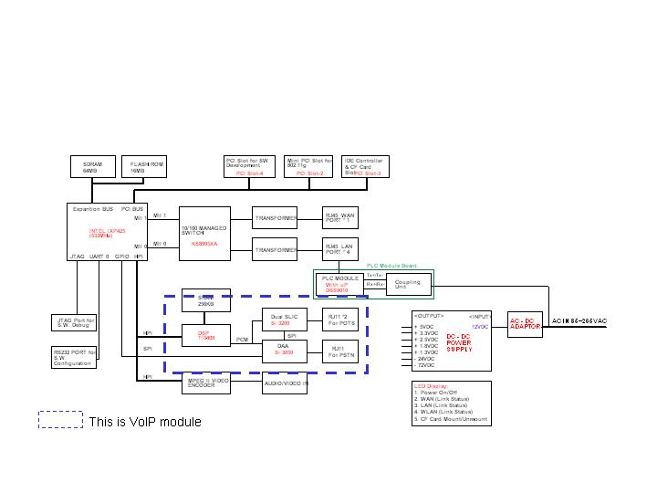
  - Adaptor

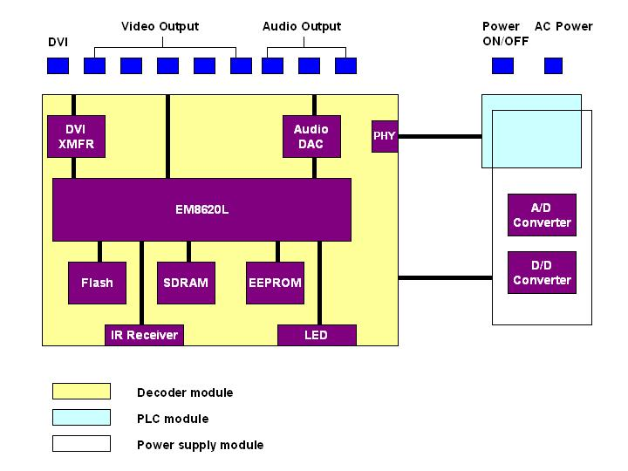

- Hardware specification

  - PLC Video & Surveillance Gateway

- CPU : IXP420 @ 266MHz
- Memory : 16MB flash memory, 64MB SDRAM
- Switch hub chip :
- USB controller
- PCI to CF
- Mini PCI connector
- IEEE802.11g mini PCI module
- Compact Flash reader
- MPEG encoder module
  - Encoder chip : SB7007
  - A/D chip : SAA 7113
  - SDRAM : 8MB
- PLC Ethernet bridge module
  - PLC modem chip : DSS9002
  - PLC AFE chip : DSS7700
  - Ethernet PHY :
  - Flash memory :
- D/D converter

6.2 Adaptor

- MPEG decoder chip : EM8620L
- Ethernet PHY
- PLC Ethernet Bridge
  - PLC modem chip : DSS9002
  - PLC AFE chip : DS7700
  - Ethernet PHY
  - Flash memory
- D/D converter

-

- Software Architecture

The software architecture of PLC video & surveillance gateway, PLC digital media adaptor and RTSP streaming are shown in the following figures
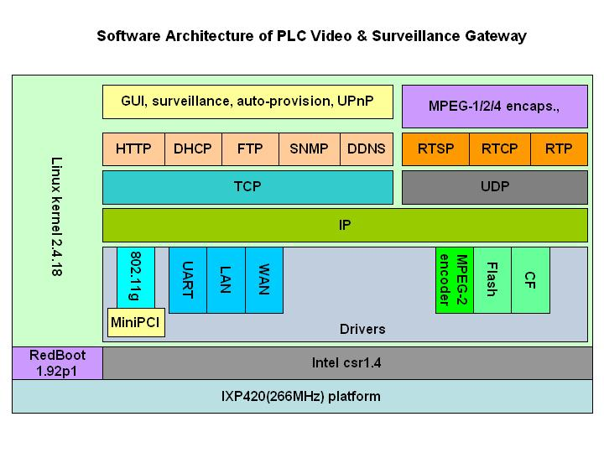
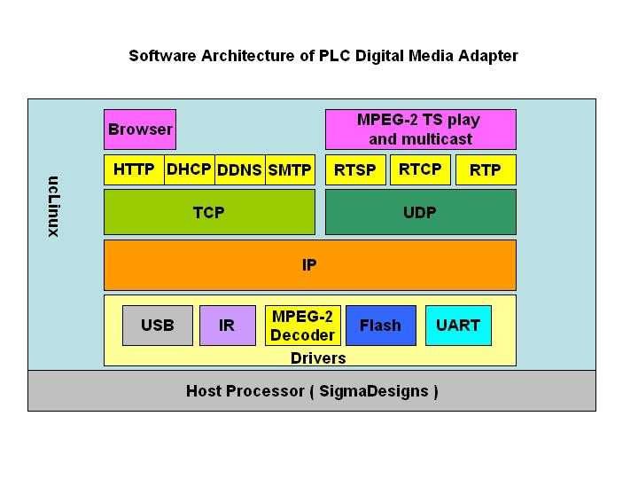
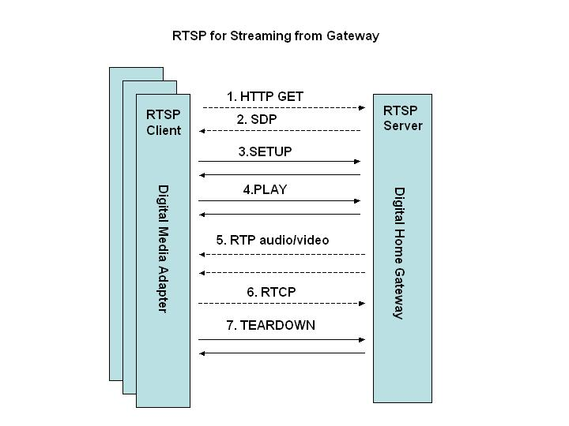

- Software Specification and Flow Chart

  - PLC Video & Surveillance Gateway

- MontaVista Linux OS 3.0, kernel-2.4.18 for system ( Note : The kernel should follow the one used in VoIP WiFi Gateway )
- Support routing
  - TCP/IP
  - RIP 1, RIP 2
  - DDNS
  - DHCP
  - NAT
  - PPTP pass-through
  - FTP

- Support iptables for firewall (Packet Filtering)
- Support UPnP
- IEEE802.11g for IP camera
- SNMP for ISP remote management
- Auto-provision function for auto-configuration from ISP’s server
- Web GUI configuration
- Support DVD/VCD movies, MP3 musics (from the local) to PLC Digital Media Adapters.
- Surveillance gateway-

  - PLC Digital Media Adaptor

- UCLinux
- Support HTTP and Mozilla browser
- Support Infrared remote control

- ID

